Nigeria IGBO Parish Council

The Igbo-Nigerian Community founded the Igbo Catholic Church Ottawa on February 28th, 2010. They began by holding monthly masses in their native Igbo language. They observed all the Catholic seasons and times, baptism, and funerals, etc but were missing being part of The Catholic Women’s League of Canada (CWL).

Mrs. Bernadette Ojiaku, began to work for their parish ladies to become CWL members. Bernadette was a long serving member of Assumption Of Our Blessed Virgin and Good Shepherd parishes and understood the CWL.

In 2021 Bernadette contacted the President of the Ottawa Diocesan, Lynn Lavictoire. She was warmly received and guided through the process of setting up a CWL council. The current President of the Ottawa Diocesan, Claudette Langdon worked with Bernadette to have the Nigeria Igbo council formally established by national and they were inaugurated on October 7, 2022. The first CWL executive of the parish were installed with Bernadette as their President. They currently have 30 members!

Bernadette is an active CWL Parish President and has represented her parish in many of the league activities held in the Ottawa Diocesan.

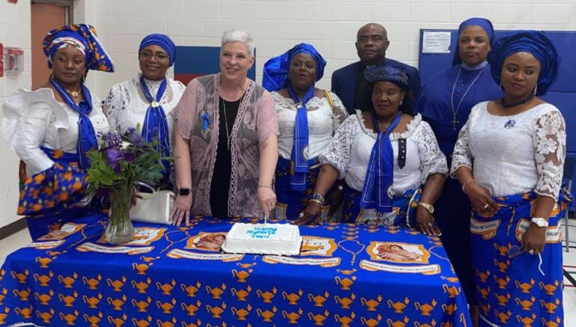

On Mother’s Day the Ottawa Diocesan Secretary, Catherine Gasper attended their meeting and provided the Unity Outreach Program. They also had a special visitor, Sister Nkechi from Holy Spirit Parish. Well done ladies!

